Cook Book: Your Virtual Kitchen Assistant
Team ID : NM2025TMID40168
Team Size: 4
* Team Leader : Baliboina Rajesh
* Team Member : AJAY B
* Team Member: Naveen Kumar p
* Team Member : STEPHANOS B
Project Objective
A virtual cookbook's project objective is to create an accessible, organized, and interactive platform for sharing recipes digitally, aiming to enhance users' cooking skills, save them time and money by utilizing available ingredients, and foster culinary community through user contributions and feedback. Key objectives can include making recipes easy to find through intuitive design, supporting dietary needs, and providing a convenient, accessible resource for users to learn and share recipes from anywhere.
Platform & Technology Used
Virtual cookbooks use a mix of web technologies, such as HTML, CSS, and JavaScript for web-based cookbooks, and mobile app development frameworks for dedicated apps, often leveraging cloud storage and APIs for features like recipe import and sharing. Platforms range from general design tools like Canva and PDF-based creation tools like Bookemon to specialized recipe apps like Paprika and Recipe Keeper.
Setup Instructions
● Download Node.js LTS version from https://nodejs.org/en/download/
● After downloading, install Node.js by opening the downloaded file and
follow the instructions below.
● After installing Node.js, open Windows PowerShell As
Administrator
● Type set-executionPolicy unrestricted and press enter
● In the next step type Y and press enter
Steps To Download And Execute Project:
● From your SmartInternz portal Go To Projects → Access Resources
→ Guided Projects → Go To Workspace

● Inside Guided Project you can find Project Flow
● Now you can see two links one is the demo video and the other is
the code drive link.
● Click on the code drive link or copy paste that link in your new
chrome tab.
● Type npm install in your terminal and press Enter and wait till all the
dependencies gets download
● After all the downloads finishes, now type npm start and press enter
● Now your application will be opened in your browser with url
http://localhost:3000
Project Structure
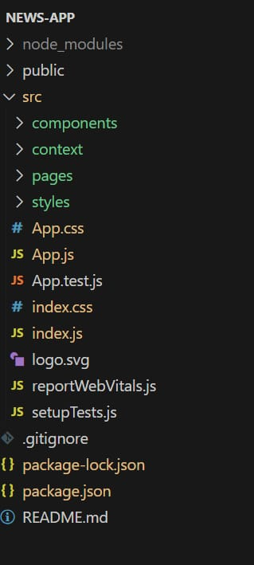

Running the Application
Provide commands to start the frontend server locally.
Frontend: npm start in the client directory.
Component Documentation
In this project, we’ve split the files into 4 major folders, Components, Context, Pages and Styles. In the pages folder, we store the files that acts as pages at different URLs in the application. The components folder stores all the files, that returns the small components in the application. The context Api will be coded in the context folder. All the styling css files will be stored in the styles folder.
Styling
CSS Frameworks/Libraries: Describe any CSS frameworks, libraries, or pre-processors (e.g., Sass, Styled-Components) used.
Theming: Explain if theming or custom design systems are implemented.
Screenshots and Demo
Before starting to work on this project, let’s see the demo.

Demo link: https://drive.google.com/file/d/11uBQ3q6BK13SlFLz1ydlbM48QeqWecFL/view?usp=share
Pre-Requisite:
*Download Node.js LTS version from https://nodejs.org/en/download/
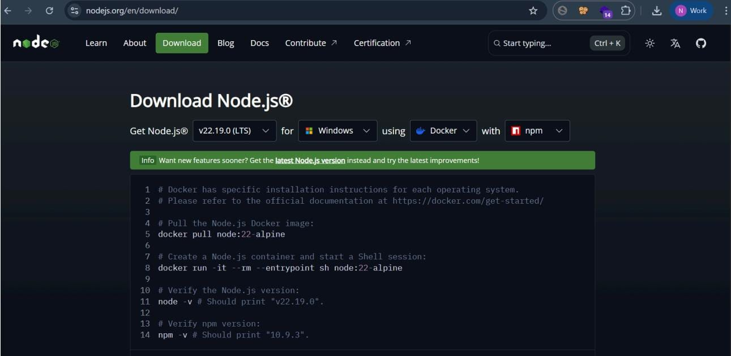
● After downloading, install Node.js by opening the downloaded file and
follow the instructions below.
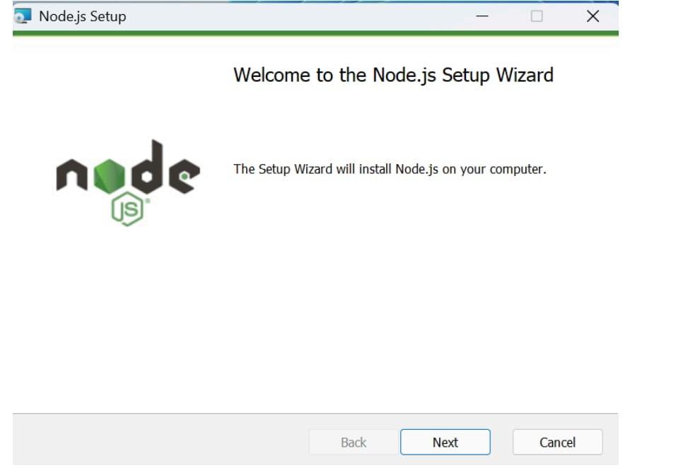
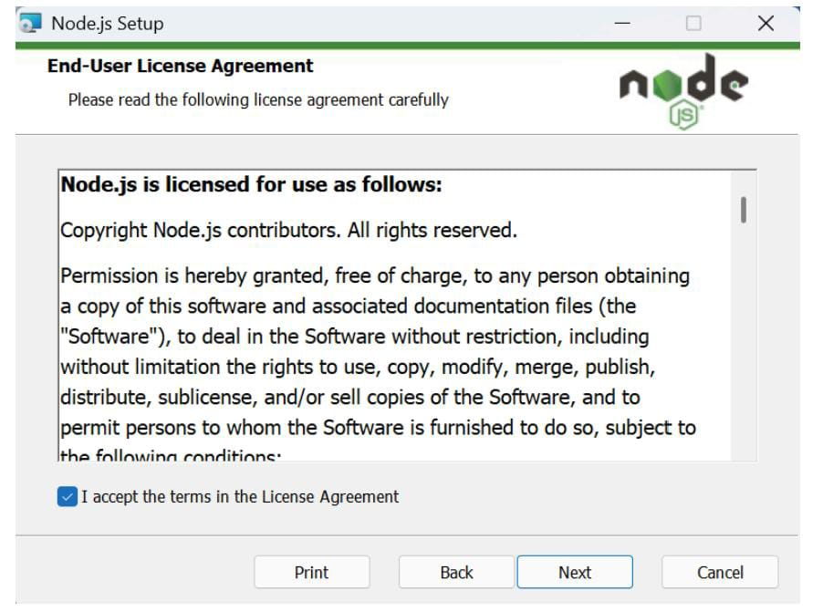
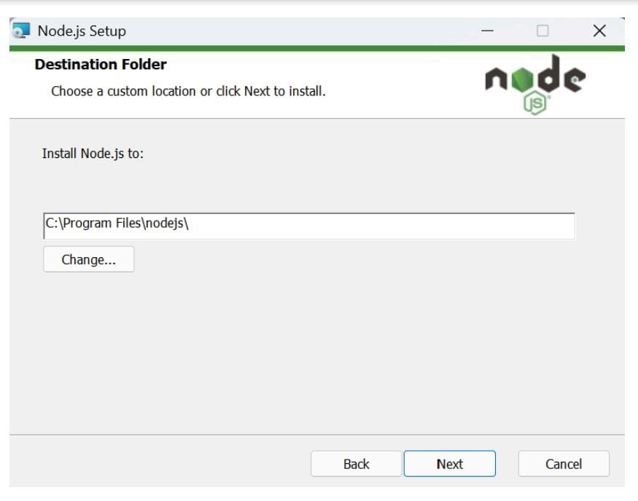
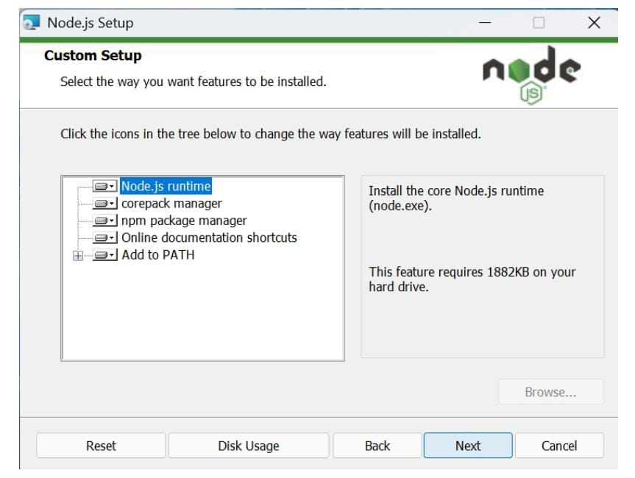
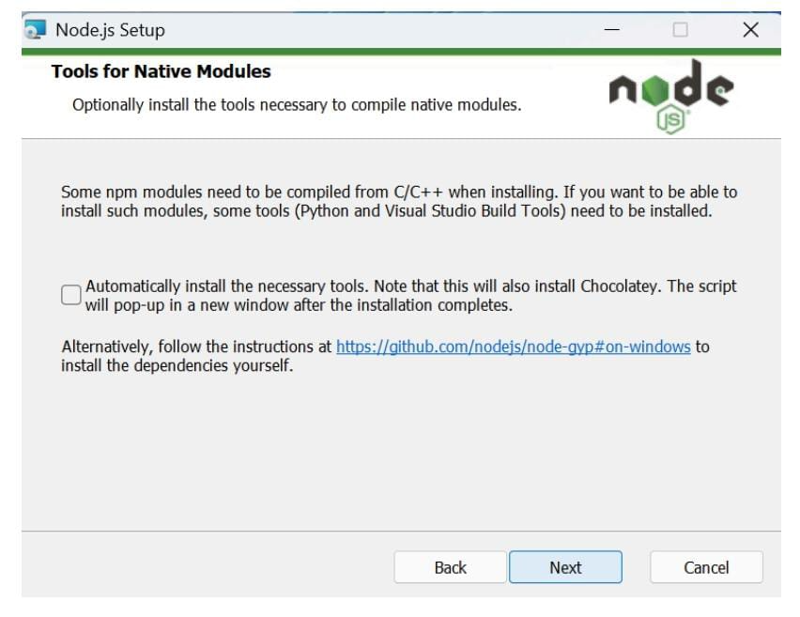
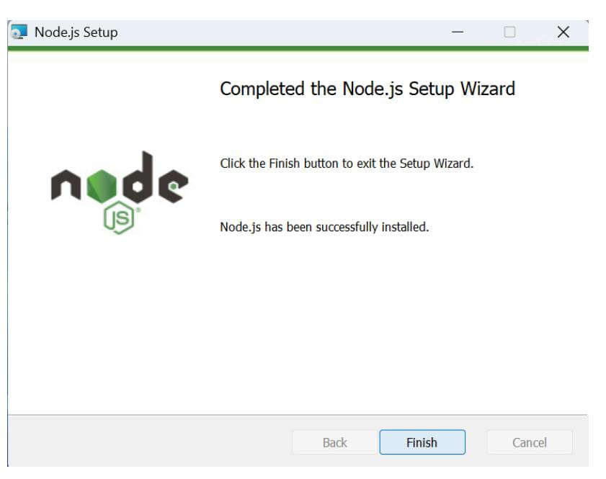
● After installing Node.js, open Windows PowerShell As
Administrator
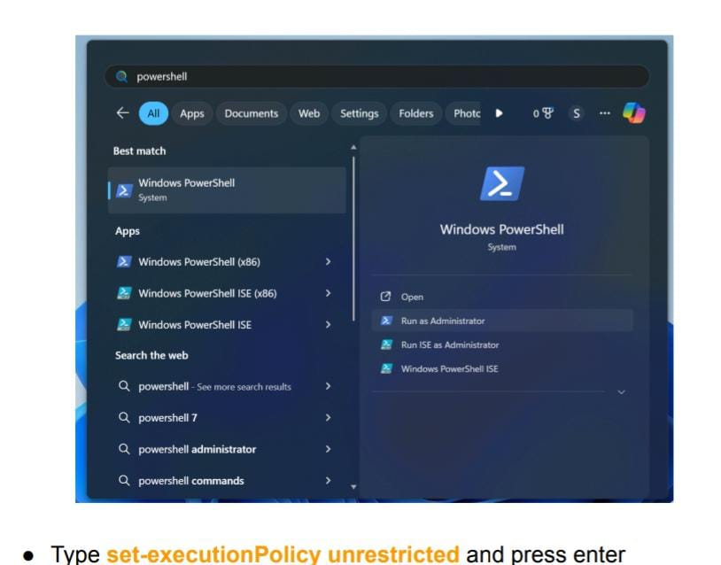
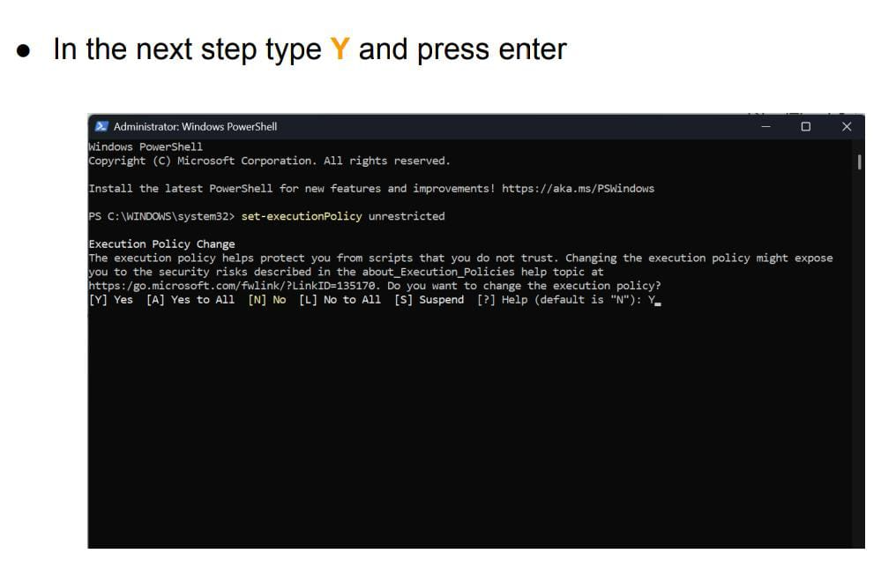
Steps To Download And Execute Project:
● From your SmartInternz portal GoTo Projects → Access Resources
→ Guided Projects → Go To Workspace
● Inside Guided Project you can find Project Flow
● Now you can see two links one is the demo video and the other is
the code drive link.
● Click on the code drive link or copy paste that link in your new
chrome tab.
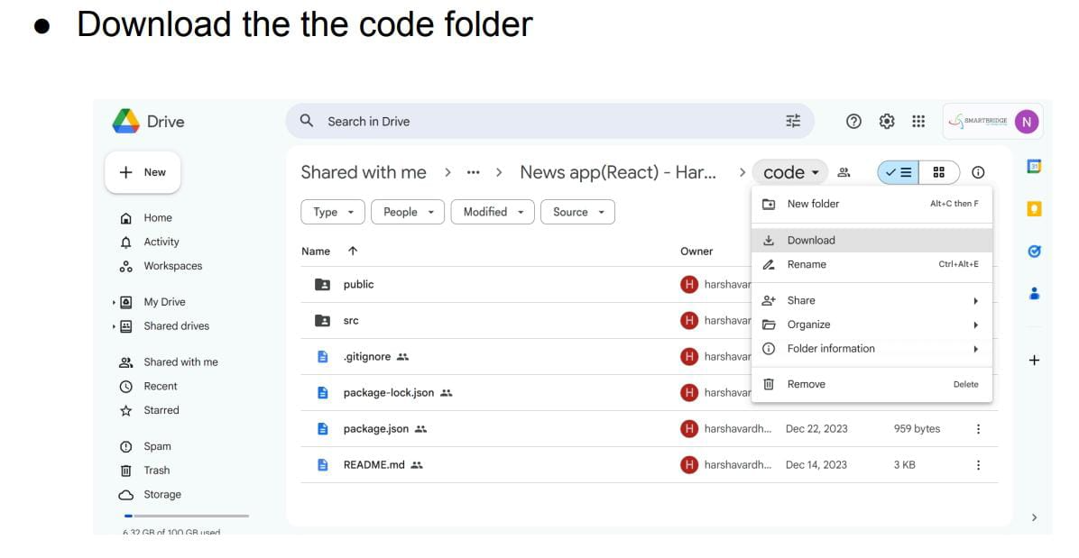
● Now go to downloads and right click on the downloaded zip folder
and click on extract all
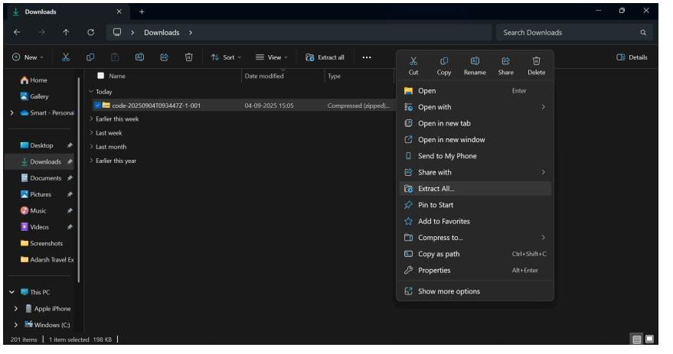
● Now open VS code and open the code folder from the extracted folder.
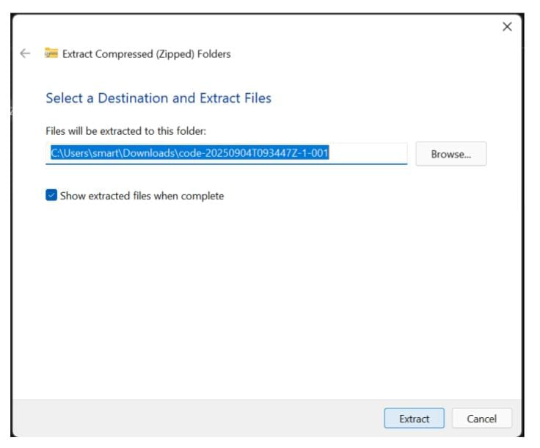

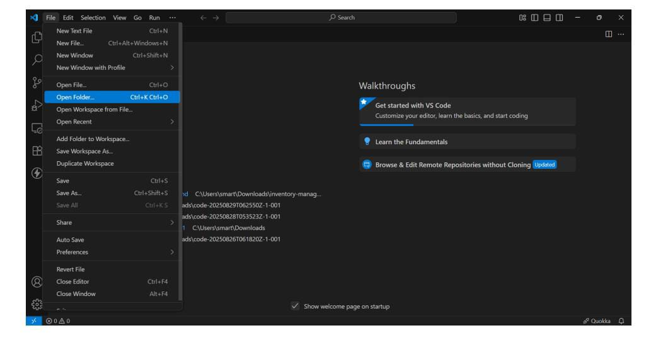
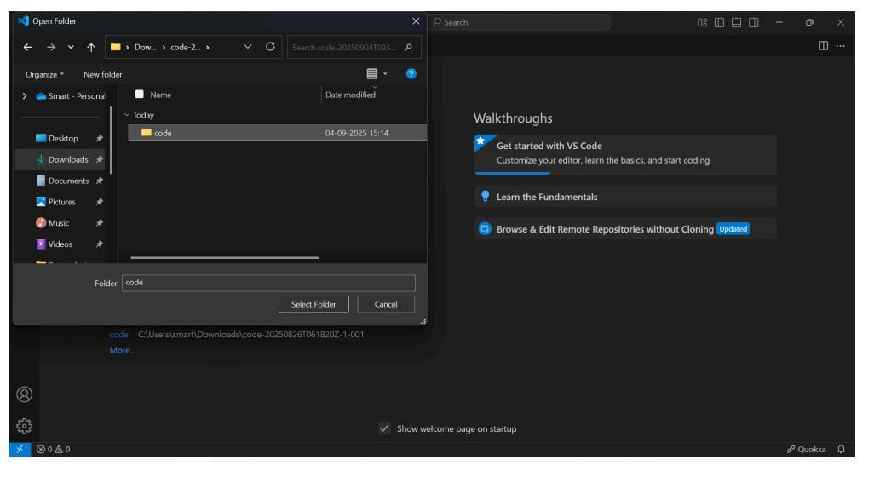
● Now open a new terminal.
● Type npm install in your terminal and press Enter and wait till all the
dependencies gets download
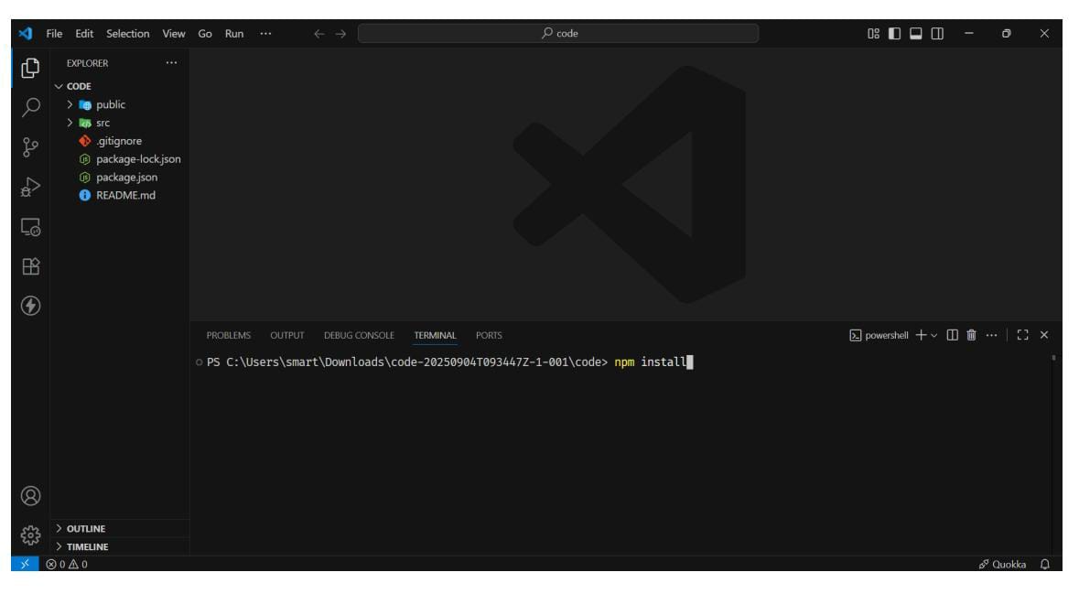
● After all the downloads finishes, now type npm start and press Enter
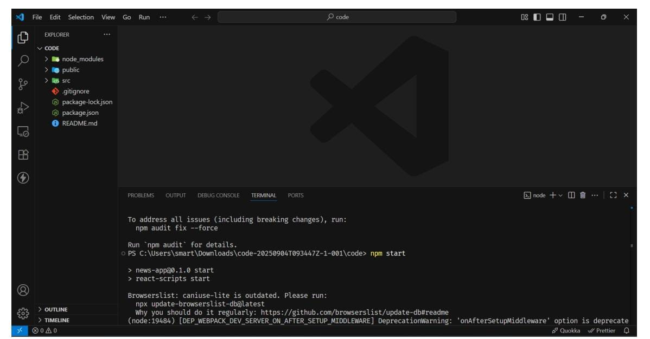
● Now your application will be opened in your browser with url
http://localhost:3000

